Activity-1:
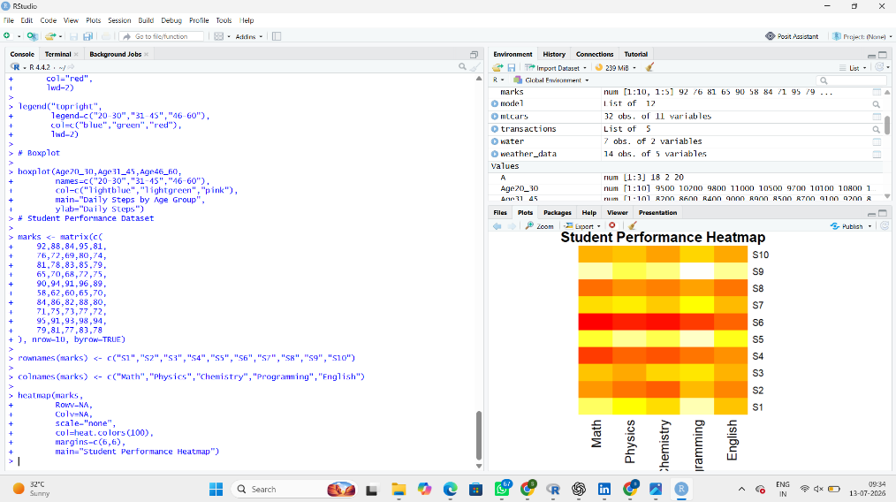
1. Construct a Heatmap: A heatmap is created to compare students' marks using different colors.
2. Identify highest overall performer: S9.
3. Find highest average subject: Programming.
4. Identify students needing support: S6 and S4.
5. Explain Heatmap advantages
- Easy to compare data.
- Shows high and low values quickly.
- Helps identify patterns.
- Easy to understand.
Activity-2:
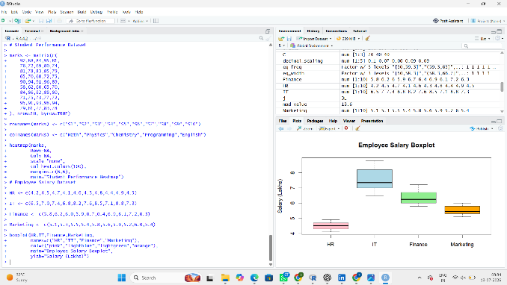
1. Draw violin plots: A violin plot shows the distribution of employee salaries.
2. Construct boxplots: A boxplot shows the minimum, maximum, median, and spread of salaries.
3. Largest variation: IT department.
4. Highest median: IT department.
5. Which plot better represents distribution?
Violin plot, because it shows both the distribution and density of the data.
Activity-03:
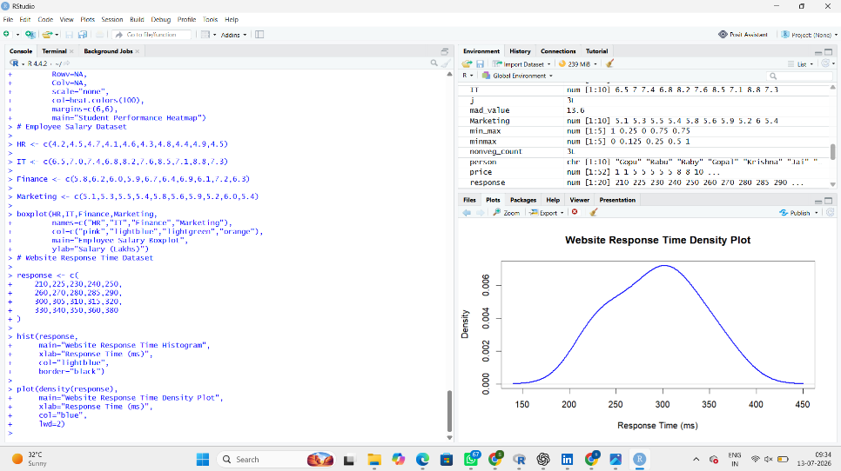
1. Draw histogram: A histogram shows the frequency of response times.
2. Plot density: A density plot shows the smooth distribution of response times.
3. Determine skewness: Slightly right-skewed (positive skew).
4. Common range: 250 ms to 330 ms.
5. Which plot better represents distribution?
Density plot, because it shows the overall distribution more clearly.
Activity-4:
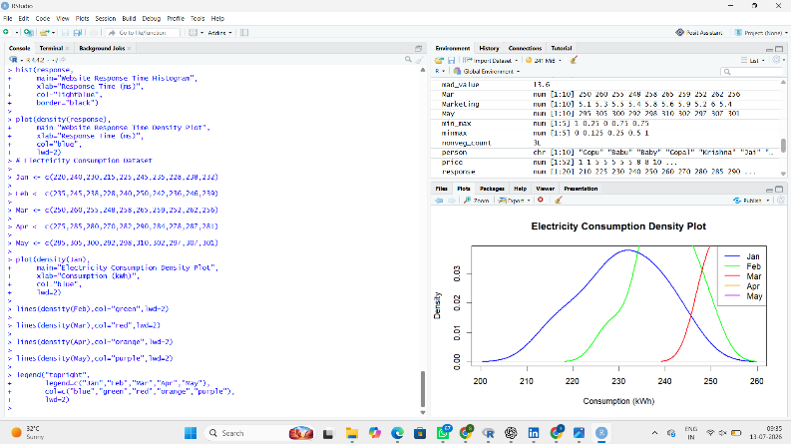
1. Create ridgeline plot: A ridgeline plot compares electricity consumption for each month.
2. Highest average month: May.
3. Widest spread: May.
4. Describe trend: Electricity consumption gradually increases from January to May.
5. Why ridgeline?
- Easy to compare multiple distributions.
- Shows trends clearly.
- Displays monthly patterns.
Activity-05:
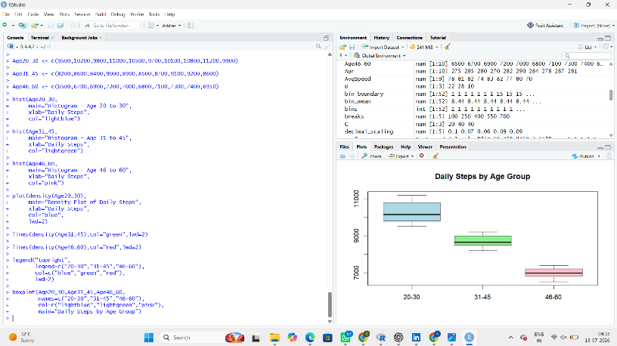
1. Draw histograms: Histograms show the frequency of daily steps for each age group.
2. Plot density curves: Density curves show the smooth distribution of daily steps.
3. Create boxplots: Boxplots compare the median, spread, and outliers of each age group.
4. Highest median group: Age 20–30.
5. Best visualization and justify
- Boxplot.
- Reason: It clearly shows the median, spread, and possible outliers, making comparison between age groups easy.

